Exp. No: 10
Verification of Faraday’s Law of Electromagnetic Induction – Determination and Plotting of Induced EMF (Transformer EMF and Motional EMF)
Test Case (i) – Transformer EMF Induced by a Time-Varying Flux Density
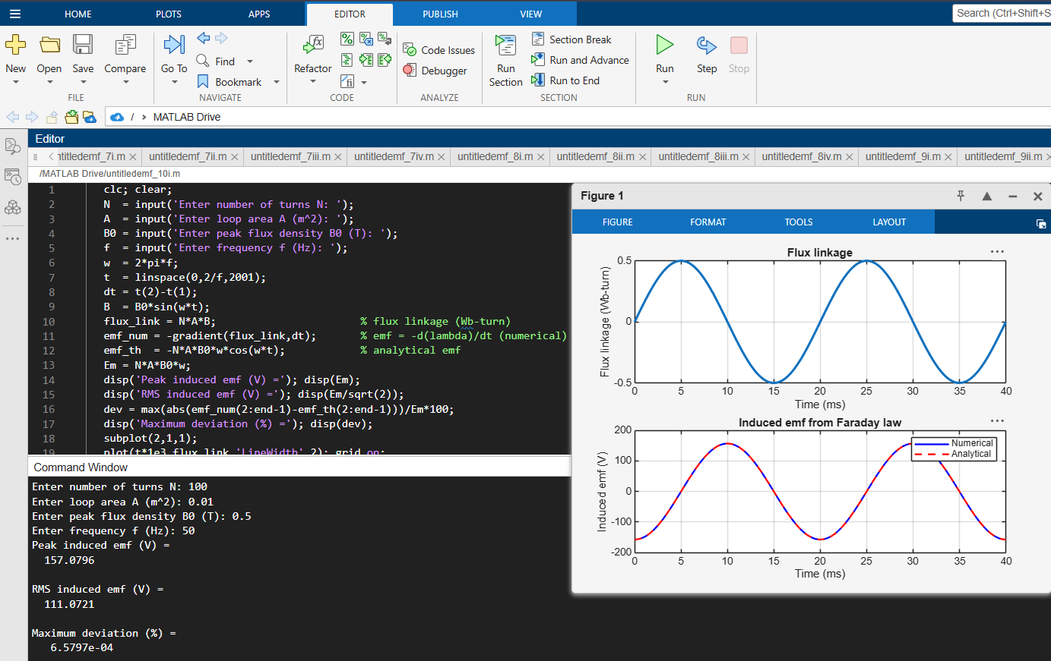
Test Case (ii) – Motional EMF of a Conductor Moving in a Magnetic Field
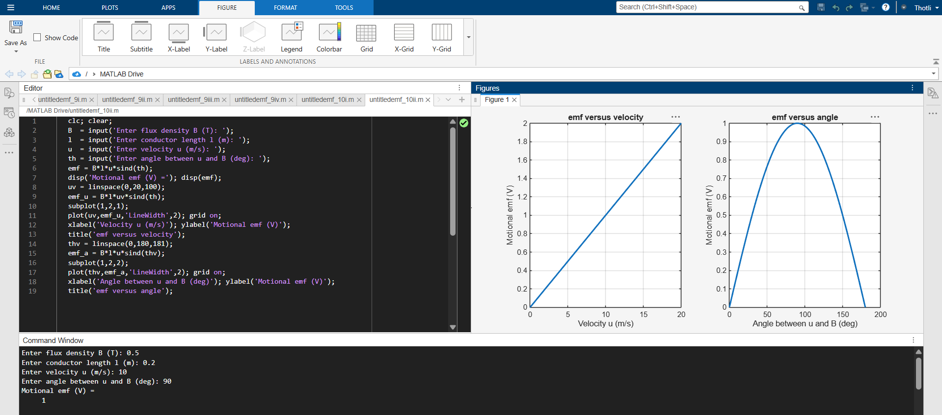

Test Case (iii) – EMF of a Rotating Loop (Generator Action)
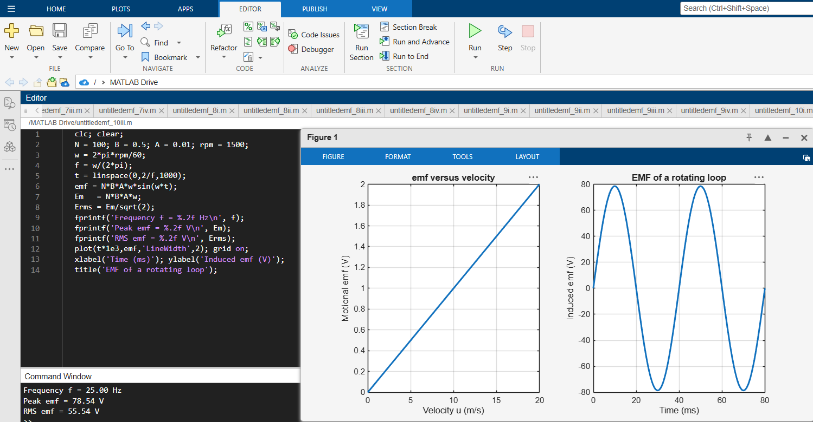
Test Case (iv) – Effect of Frequency and Number of Turns on the Peak EMF


